# 3D Model Reconstruction

1st Presentation

Ajith K B Turbo Intern Wipro

# Method: 3D R2N2

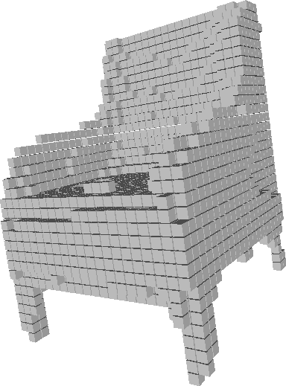

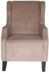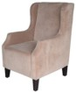

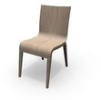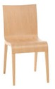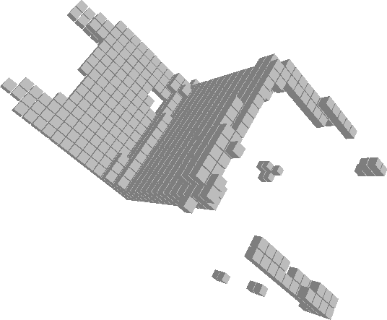

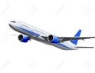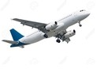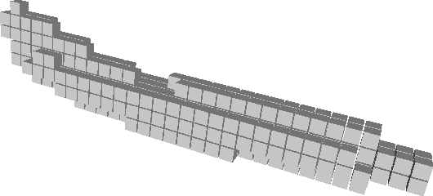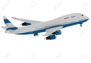

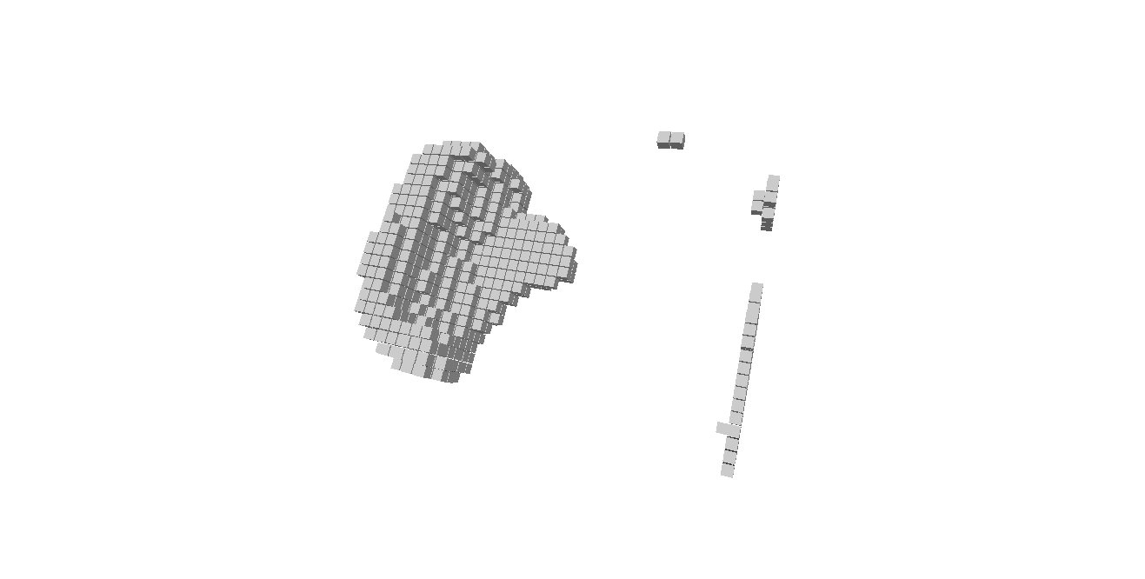

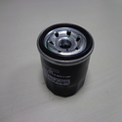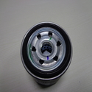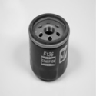

Next Step/challenges

* Looking for new improoved network which covers baseline issue.
* Tensorflow implimentation
* Need to create dataset for our purpose.
* GPU Mechine Required For training

# Thank you